**Advanced Databases - LAB Week 10**

**Indexes and Query Optimization**

Dr. Pierpaolo Dondio

In this lab we will experiment with query optimization.

Create the following tables:

1. Persons
2. Jobs
3. Jobs-persons

A list of persons is connected many-to-many to a list of jobs (the table jobs-person is the relation table).

drop table persons;

create table persons(

person_id integer,

person_name varchar(20),

person_surname varchar(20),

person_age integer not null,

person_wealth integer,

person_weight float

);

drop table jobs_person;

create table jobs_person(

jobs_id integer,

person_id integer,

start_date date,

end_date date);

drop table jobs;

create table jobs(

jobs_id integer,

job_description varchar(200),

salary integer

);

Execute the following sql 3 commands block **ONE BY ONE** to fill the tables with random data. The commands are also in the *populate.sql* (but execute them one by one!!)

/* 1. populate table persons */

declare v_p_id number;

v_p_name varchar2(20);

v_p_surname varchar2(20);

v_p_age integer;

p_wealth float;

p_weight float;

BEGIN

FOR i IN 1..10000 LOOP

select DBMS_RANDOM.STRING('a', 20) into v_p_name from dual;

select DBMS_RANDOM.STRING('a', 20) into v_p_surname from dual;

SELECT TRUNC(DBMS_RANDOM.VALUE(18, 100)) into v_p_age FROM DUAL;

SELECT TRUNC(DBMS_RANDOM.VALUE(0,10000000)) into p_wealth FROM DUAL;

SELECT trunc(DBMS_RANDOM.VALUE(40, 120),2) into p_weight FROM DUAL;

insert into persons values(i,v_p_name,v_p_surname,v_p_age,p_wealth,p_weight);

END LOOP;

end;

/* 2. populate table jobs */

declare j_id number;

j_description varchar2(100);

j_salary float;

BEGIN

FOR i IN 1..10000 LOOP

select DBMS_RANDOM.STRING('a', 100) into j_description from dual;

SELECT TRUNC(DBMS_RANDOM.VALUE(0,100000)) into j_salary FROM DUAL;

insert into jobs values(i,j_description,j_salary);

END LOOP;

end;

/* 3. populate table jobs-persons */

declare j_id number;

p_id integer;

start_date date;

end_date date;

st integer;

en integer;

BEGIN

FOR i IN 1..10000 LOOP

FOR j in 1..15 LOOP

SELECT TRUNC(DBMS_RANDOM.VALUE(0,1000000)) into p_id FROM DUAL;

SELECT TRUNC(DBMS_RANDOM.VALUE(0, 1000)) into st FROM DUAL;

SELECT TRUNC(DBMS_RANDOM.VALUE(0, 2000)) into en FROM DUAL;

SELECT TO_DATE(TRUNC(DBMS_RANDOM.VALUE(2452641,2452641+st)),'J') into start_date FROM DUAL;

SELECT TO_DATE(TRUNC(DBMS_RANDOM.VALUE(2452641+st,2452641+st+en)),'J') into end_date FROM DUAL;

insert into jobs_person values(i,p_id,start_date,end_date);

END LOOP;

END LOOP;

end;

There are no keys or indexes defined. The person_id and the jobs_id are unique.

Using the oracle function Explain Plain (in SQL developer is the fourth icon from the left in the sql script window or press F10), we3 will analyse how ORACLE executes queries and the cost of each query - a number expressing how much resources and time your query takes.

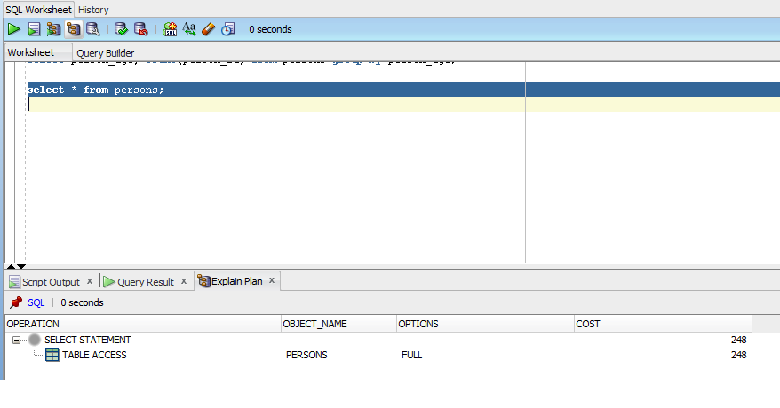

Execute the following steps to analyse Oracle Index behaviour

1. Check that data are in the three tables. Have a look at the data

There are no indexes or keys defined at this stage.

1. Execute the following query

**Query1.**

*select * from persons*

And select the explain plain function.

How much is the cost? ______27___- Cardinality 11138________________________

Was it a full or index scan of the table? __Full Scan____________________________

Why? ____There is no index so it must be a full scan___________________________

______________________________________________________________________

1. Execute

**Query2 .**

*select * from persons where person_id>1000 and person_id<3000*

Total cost? ___27__- Cardinality 2171______________________________________

Full or index scan? Why? ____Full Scan______________________________________

Any difference with the previous query? __There is a range used__________________

1. Define a primary key over *person_id* (using an ALTER TABLE … ADD CONSTRAINTS statement) Remember that this creates an index on *person_id* as well. Perform **Query1**

Cost? ____________________27___- Cardinality 11138____________________________

Full or Index? ___________________Full Scan_____________________________________

Comment the results.

________Index hasn’t made a difference to the scan since its still a full scan ______________________________________________________________________________________________________________________________________________________

Perform **Query2**

Cost? ______3_________- Cardinality 2171__________index (2 – Cardinality 50)_________

Full or Index? _______This is an index scan________________________________________

Comment the results.

___________The index has now improved the efficiency/cost of this query considerably ______________________________________________________________________________________________________________________________________________________

Query1 requires a full scan since it gives back the full unfiltered table

Query2 requires uses the index scan on the primary index *person_id* to filter the data. Note that range scan refers to accessing an interval of value (range) using an index (therefore oracle finds the starting point using the index and then the scan is sequential over an ordered list. It is therefore faster than full scan)

1. Perform the following

**Query3**

*select * from persons where person_id+5>1000 and person_id<3000*

Check cost and type of scan

Cost: __3 – Cardinality 2179 _____________2 – 5__________________________________

Type of Scan ______Index Scan________________________________________________

**Query4**

*select * from persons where person_id+5>1000 and person_id*2<3000*

Check cost and type of scan

Cost: ________27 - Cardinality 406_____________________________________________

Type of Scan _____Full Scan___________________________________________________

Comment the behaviour of Query3 and Query4

____The query 3 uses the index of the second person_id. The query 4 cannot use either index since they are both being added/multiplied, so it uses a full scan instead.________________________________________________________________________________________________________________________________________________

In **Query3** the index person_id is contained in the expression (person_id+5) so it cannot be used. However, the index can be used in the other where clause (person_id<20000), so Oracle performs an index access of the table to get the persons with person_id<20000 and at the same time it filters the condition (person_id+5>20000)

In **Query4**, none of the index can be used so a full scan is performed

Remember: if an index is used in an expression that affects the ordering of the data , it won’t be used!

1. Execute

**Query5.**

*select person_age, count(person_id) from persons group by person_age;*

Cost? _____28 – Cardinality 1118 ______________________________________________

Full or Index? _____Full Scan___________________________________________________

Comment the results.

_____The index for person id is not used so because of the group by part of the query _____________________________________________________________________________________________________________________________________________________

The index on *person_id* does not help since we are grouping by person_age, so a full scan is required. Note the extra cost of grouping, executed by Oracle in a quick way by hashing the persons by age during the full scan

1. Define an index on person_age by executing:

*create index p_age on persons(person_age);*

Execute again **Query5**

Cost? ________8 – Cardinality 11138 ___________________________________________

Full or Index? ____Full scan__(FAST)_____________________________________________

Even if an index is defined on person_age, the index is not used, why?

The reason is the following (IMPORTANT!): if a column contains NULL values or it has been defined (with CREATE TABLE) without NOT NULL the index will be ineffective!

1. Drop the table persons.
2. Modify the create table statement adding “*not null*” to the field *person_age (*and add primary key to the *person_id* field so you do not need to alter the table afterwards).
3. Populate the table with the sql command used before (page 2, block 1)
4. Execute query5

Cost? ___27 without p_age, 8 with p_age index___________________________________

Full or Index? __Full Scan without p_age, Full Fast Scan with it________________________

You should see an index-like access (hash, i.e. the type of index create on person_age – default) and the cost is now reduced

1. Joining two tables

Perform the following query:

*select jobs.jobs_id,jobs.job_description, jobs.salary, jobs_person.person_id*

*from jobs inner join jobs_person*

*on jobs.jobs_id = jobs_person.jobs_id*

*where jobs_person.jobs_id=34;*

Cost? _____260, Cardinality 69________________________________________________

Full or Index? _____Full Scan___________________________________________________

Comment the results.

________The join query uses two full table query scans, and a hash join to speed it up __________________________________________________________________________________________________________________________________________________________________________________________________________________

Note how the query is divided into steps: first the full scans and the hash table used to speed-up the join.

Add indexes on jobs_id.jobs_id and jobs_person.jobs_id (note that one could be aprimary key and the other a foreign key).

Check again the results.

Did they improve or not? Why?

(you should see a reduction in cost due to the usage of indexes).

1. Reduce the cost of this query as much as you can:

/* select person name, max salary and job description between 2003 and 2004 */

*select p.person_name, j.salary, j.job_description*

*from persons p inner join jobs_person jp on p.person_id = jp.person_id*

*inner join jobs j on jp.jobs_id=j.jobs_id*

*where jp.start_date> '01-JAN-2003' and jp.end_date < '31-DEC-03';*

Cost? _____246, Cardinality 27724_____________________________________________

Full or Index? _____Full Scan__________________________________________________

drop index p_age;

drop index jp_end_date;

drop index jp_start_date;

create index p_age on persons(person_age);

create index jp_start_date on jobs_person(start_date);

create index jp_end_date on jobs_person(end_date);

Cost? _____244, Cardinality 27724_____________________________________________

Full or Index? _____Full Scan__________________________________________________

drop table temp1;

create table temp1 as select p.person_id, p.person_name, j.salary, j.job_description

from persons p inner join jobs_person jp on p.person_id = jp.person_id

inner join jobs j on jp.jobs_id=j.jobs_id;

select person_name, salary, job_description

from temp1 inner join jobs_person jp on temp1.person_id = jp.person_id

where jp.start_date> '01-JAN-2003' and jp.end_date < '31-DEC-03';

Cost? _____180, Cardinality 1569_____________________________________________

Full or Index? _____Full Scan__________________________________________________

Alternative – offload whole query to temp1

*create table temp1 as select p.person_name, j.salary, j.job_description*

*from persons p inner join jobs_person jp on p.person_id = jp.person_id*

*inner join jobs j on jp.jobs_id=j.jobs_id*

*where jp.start_date> '01-JAN-2003' and jp.end_date < '31-DEC-03';*

*select * from temp1;*

Cost? _____4, Cardinality 360_____________________________________________

Full or Index? _____Full Scan___________________________________________________

Use indexes, temporary tables, change the SQL code, split the join – but be sure the result is still equivalent!